3D Printing orthotics
SCAN PRINT FIT

- Background:
Nowadays with the new technology has emerged one of the fantastic method to use, is the manufacturing orthoses using the computer. Using the computer to manufacture orthoses is beneficial in many ways, such as, eliminating waste of time, money, workers, and product accuracy. Of course, computer aided design (CAD) is helpful to do the casting and calculate the time. While the computer aided manufacturing (CAM) is to control the fabrication of the materials and control it.
- Additive advantage:
At Prosthetics, it delivers the maximum power of open source hardware printers, which it can be modified and build off to specifically to meets the needs that our industries need.

- Purpose:
Therefore, the purpose for this orthotics is to discover and approach a new method to manufacture orthotics for the foot or wrist for more benefits to lower the costs and help satisfy the needs. Also, to develop a new method to manufacture this orthotics in future.
- Aim:
- Durable.
- Reliable.
- Affordability.
- Methodology/Manufacturing:
Using prototype and other system tools to design the orthotics is very important in this method; lately many researchers have been developing this type of method to make it more beneficial to the market and patients. However, to make this approach without mistakes, we have to use specific technologies such as 3D-digitizing and other machines that will assist to manufacture.
- Customer Specifications: is important for the person who will use the orthosis, since it is adjustable to the position that needs orthotics to align the foot and ankle into the most anatomically efficient position. Also, accurate measurement strongly required as well as the materials for perfect production.
- FO with adjustable metatarsal support element:
This modification is intended to redistribute a metatarsal head using an FO modification which also known as dome. However, this feature can be added as an intrinsic part of the device at the design stage.
- Findings:
So the current method to manufacture a 3D impression of a patients’ foot are the plaster and foam box casting. Each of these casting methods is subject to practitioner error and can result in excess waste. Moreover, when compared to the new technology which is using the computer and save the waste to be recycled for other use. Furthermore, the cost will be different and much more less to use the new technology.
- Effects:
The purpose for this research is to determine if the orthotics is really good to use and the result of using it. So researchers have applied the idea to 52 subjects were chosen randomly into either experimental group or control group. “The experimental group showed more improvement than the control group in the BBS, TUG and PASS scores, but the differences were not significant. In the comparisons within the groups by time, both groups showed significant improvement in BBS, TUG, and PASS scores.”
- Medical:
- Artificial Organs: researchers and scientists have been developing many ways to print artificial organs, such as kidney and liver structures. One of the things that help doctors in surgeries, is the 3D printing like the artificial heart. Moreover, pins or screws that assist the bone to strengthen the structure are helpful but overtime, these materials could cause infections or arthritis.
- Bionic Limbs:
“According to Amputee Coalition, there are approximately 2 million US residence living with limb loss, with another 185,000 added each year.” Furthermore, “In the case of young children, the difficulties of limb loss are twofold because children require 1) high mobility and 2) a solution that addresses the steady physical growth of the child. Parents of children like Alex Pring, a six-year-old boy who was born without his lower right arm, are faced with traditional options of prosthetics and bionics. These can cost upwards of $40,000 and will be rapidly outgrown as the child develops.”
- Personal:
-Maintenance:
Maintenance and spare part is an important point that highlight the complexity to keep the maintenance for the orthosis. Also, the insurance to do that is expensive too, but using computer aided design (CAD) at the lower cost we could manufacture 3D product in lowest cost.
- Affordability: orthotics can cost from $10 to $80, while non-remedy custom insole produced using a do-it-without anyone else's help form of the patient's feet can cost from $100-$200 without protection, according to CostHelper.com. The cost for custom orthotics keeps running from $400 to $600 by and large.
- Innovation:
Defenders of the innovation propose that 3DP offers a superior approach to make devices, as well as a superior approach to make enhanced devices.
- Types:
- AFO (Ankle Foot Orthosis).
- KAFO (Knee Ankle Foot Orthosis).
- KO (Knee Orthosis).
- Design:
- Foot Orthotics:
- Functional
- Comfortable
- Central FAB: 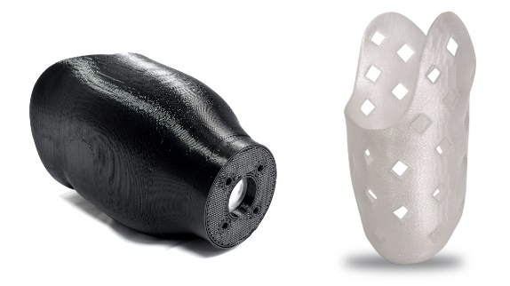
- Prosthetics:
- AK + BK
- AE + BE
- Cover
- Orthotics:
- Orthotic Inserts
- AFO + KAFO
- Others.

Amphibian:
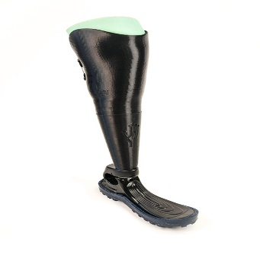
Is perfect below the knee device that will assist you on your daily activities such as swimming, riding ATV, or doing your recreational activities. Besides that, the leg is also simple to pack it in a suit case or even in tight storage places.
- Affordable
- Multi-Purpose
- Custom Fit
- Waterproof
- Niagara Foot: 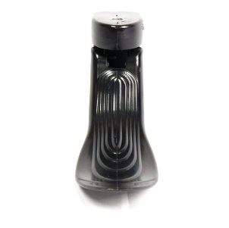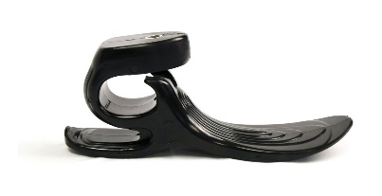
- Versatile
- Durable
- Affordable
- Adjustable
- Pectus Carinatum Brace: 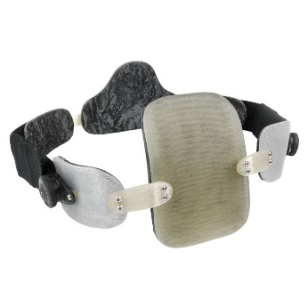
- Low-Profile
- Customized
- Lightweight
- comfortable

- Discussion:
- “The orthotic made from the 3D printing method resulted in a higher AHI than the shod condition, indicating that the orthotic restricted motion of the medial longitudinal arch during mid-distance. The differences between the three conditions were minimal (within 0.8 mm) and variability was similar with standard deviations within 0.13 mm; however, statistical analysis was not performed since the findings are based on only one participant. The main limitation of this study is the sample size of only one, providing only a preliminary description of this developing model. Testing additional participants may reveal a more significant trend in the outcome measures using this highly affordable and accessible 3D scanning and printing method.”

- Cost Analysis:
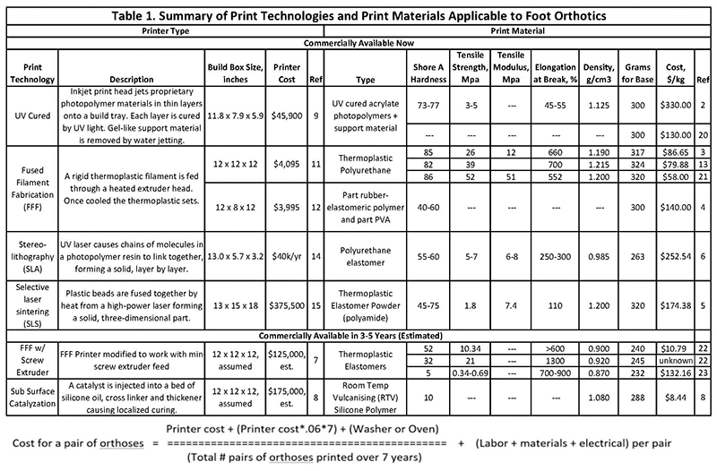

Citations
http://www.emeraldinsight.com/doi/abs/10.1108/RPJ-03-2012-0027
https://www.jstage.jst.go.jp/article/jpts/27/5/27_jpts-2014-851/_article
https://www.ncbi.nlm.nih.gov/pmc/articles/PMC4114407/
https://search.proquest.com/docview/215289926/fulltextPDF/A73483F7284848F2PQ/1?accountid=28365
https://blog.trimech.com/medical-3d-printing-part-1-prosthetics-orthotics-bionics

